

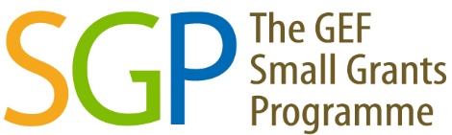

2020-2025
SMALL GRANTS PROGRAMME
COUNTRY RESULTS MONITORING REPORT

PALESTINE, STATE OF

COUNTRY PORTFOLIO
Country Programme | Palestine, State of
Year Started | 1999
Portfolio since Inception | GEF |  | Non-GEF |  | Total
Number of projects | 175 |  | 5 |  | 180
Grant amount committed | 5,780,289 |  | 70,682 |  | 5,850,971
Project level co-financing in cash | 1,309,318 |  | 7,000 |  | 1,316,318
Project level co-financing in kind | 2,004,070 |  | 13,449 |  | 2,017,519
Source: SGP database as of September 2025
 | July 2020 - June 2021 | July 2021 - June 2022 | July 2022 - June 2023 | July 2023 - June 2024 | July 2024 - June 2025 | Total  2020 - 2025
Focal Area Distribution (by completed GEF projects)
Biodiversity | - | 5 | - | - | 2 | 7
Climate Change | - | - | 5 | - | 4 | 9
Capacity Development | - | - | 1 | - | - | 1
Chemicals and Waste | - | - | 1 | - | - | 1
GEF Projects Completed | - | 5 | 7 | - | 6 | 18
Source: Reporting by Country Programme as part of the Annual Monitoring Process. Verified/updated in previous country monitoring reports.

RESULTS ACHIEVED 2020-2025
Kindly note that the values 2020-2023 have undergone quality assurance by SGP country teams in previous process of producing Country Results Monitoring Report
 | July 2020 - June 2021 | July 2021 - June 2022 | July 2022 - June 2023 | July 2023 - June 2024 | July 2024 - June 2025 | Total  2020 - 2025
PROGRESS TOWARDS FOCAL AREA OBJECTIVES
Biodiversity
Number of Biodiversity projects completed | - | 5 | - | - | 2 | 7
Number of Protected Areas (PAs) positively influenced | - | - | - | - | 1 | 1
Hectares of PAs | - | - | - | - | 70 | 70
Hectares of ICCAs | - | 5 | - | - | - | 5
Number of biodiversity-based products sustainably produced | - | 3 | 9 | - | - | 12
Number of significant species conserved | - | 5 | - | - | - | 5
Number of target landscapes/seascapes under improved community conservation and sustainable use | - | 5 | - | - | - | 5
Hectares of target landscapes/seascapes | - | 7 | 1 | - | - | 8
Climate Change
Number of Climate Change projects completed | - | - | 5 | - | 4 | 9
Hectares of forests and non-forest lands with restoration and enhancement of carbon stocks | - | - | - | - | 20 | 20
Breakdown of projects
Energy efficiency solutions projects | - | - | - | - | 1 | 1
Conservation and enhancement of carbon stocks projects | - | - | - | - | 3 | 3
Chemicals and Waste
Number of Chemicals and Waste projects completed | - | - | 1 | - | - | 1
Capacity Development
Number of Capacity Development projects completed | - | - | 1 | - | - | 1
Number of civil society organizations with strengthened capacities | - | - | 60 | - | - | 60
Number of people with improved capacities to address global environmental issues at the community level | - | - | 90 | - | - | 90
GRANTMAKER PLUS
Gender
Number of gender responsive completed projects | - | 5 | 7 | - | 6 | 18
Number of completed projects led by women | - | 2 | 5 | - | 3 | 10
Programme Management: NSC gender focal point (yes/no) | Yes | Yes | Yes | Yes | Yes | 5
Youth
Number of completed projects that included youth | - | 2 | - | - | 3 | 5
Programme Management: NSC youth focal point (yes/no) | Yes | Yes | Yes | Yes | Yes | 5
BROADER ADOPTION (Scaling up, Replication, Policy Influence, Improving Livelihoods)
Projects with policy influence | - | - | 1 | - | - | 1
Projects improving livelihoods of communities | - | 4 | 6 | - | 4 | 14
PROGRAMME EFFECTIVENESS
Peer-to-peer exchanges conducted | - | 2 | 5 | - | - | 7
Community-level trainings conducted | - | 2 | 5 | - | - | 7
Number of projects monitored through field visits | - | 11 | 7 | 1 | 8 | 27
PROGRAMME MANAGEMENT
National Steering Committee
Number of NSC meetings occurred during the reporting period | 3 | 3 | 3 | 4 | 5 | 18
Average number of NSC members that participated in each NSC meeting | 8 | 7 | 7 | 6 | 6 | 7
Average time in days needed to replace NSC member | 30 | 60 | 90 | 90 | 60 | 66

GRAPHICAL REPRESENTATION OF KEY RESULTS
The bars in the graphs indicate the number of years that the country programme has achieved specific results. If a bar is absent, it indicates that while the associated result is not observed in the country programme, it is still evident in the overall aggregated SGP portfolio.

EXAMPLES OF PROJECT RESULTS

South-South Exchange
In May and June 2022, SGP Morocco facilitated the participation of the High Atlas Foundation in regional online training on wastewater treatment for their reuse. Organized within the framework of the “Water and Environment Support” project funded by the European Union, the training enabled the capacity building and the exchange of experiences among more than 60 people representing the Mediterranean Partner countries (Algeria, Egypt, Israel, Jordan, Lebanon, Morocco, Palestine, and Tunisia) on the appropriate treatment of wastewater by focusing on small wastewater treatment plants. The exchange took place in four 4-hour sessions which strengthened the practical skills in terms of planning, construction, and exploitation of small wastewater treatment facilities. (Source: Annual Monitoring Report, 2021-2022)

ALIGNMENT OF OP7 COUNTRY PROGRAMME STRATEGY WITH NATIONAL PRIORITIES
SGP OP7 will continue to reflect national priorities as shown in the implementation of international conventions, programs/projects that are indicated in the table below.
List of relevant conventions and national/regional plans or programmes:
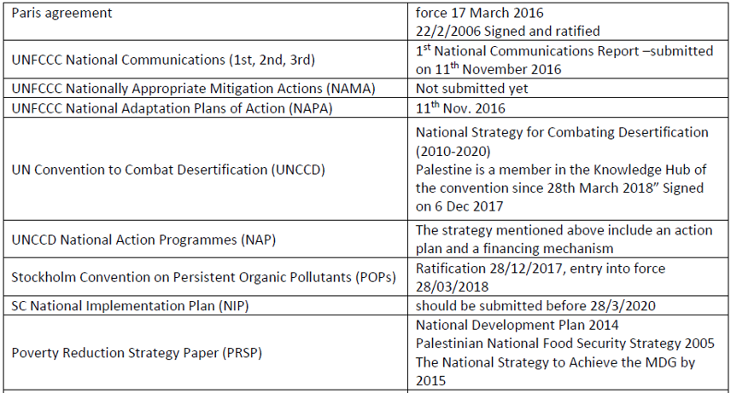
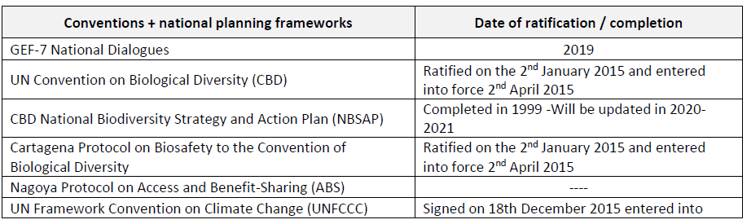

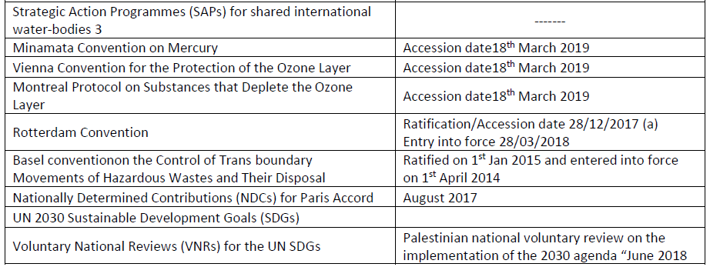

UNDP-implemented Small Grants Programme is delivering integrated results at the country level supporting local level capacities aligned with multiple Multilateral Environmental Conventions. This includes support to work for CBD National Biodiversity Strategy and Action Plan (NBSAP), UNFCCC Nationally Determined Contributions (NDCs), Nationally Appropriate Mitigation Actions (NAMA) and National Adaptation Plans of Action (NAPA), UNCCD National Action Programmes (NAP), and localization of Sustainable Development Goals, amongst many others.

METHODOLOGICAL BASIS OF COUNTRY REPORT
- Results aggregations over time are only for completed projects.

- With SGP's rolling modality, results reflect all ongoing operational phases during the indicated period. Please refer to the total projects completed on the first page for information in this regard.

- The source of reported results is the annual monitoring process, which is part of the annual monitoring requirements for each country programme. Additionally, evaluative evidence sources have also been leveraged, if available for the country programme.

- This results report benefits from extensive quality assurance. All information across all countries in the portfolio is harmonized, verified, and evidenced before being reported. Several layers of this quality assurance have been implemented in the generation of this report and there are no result duplications across years. This point is important not only for a specific unit of measurement (i.e., indicator selected) but also for results aggregation across years in a given operational phase. Reported results include both direct and indirect global-environmental and socio-economic benefits. This is due to SGP's work in two key areas:

- SGP works towards behavioural change at individual, organizational, and community levels. Social determinants that shape human interaction with the environment play an important role, especially at the community level, as sustainability and the continuation of environmental gains often depend on them. These factors include positive shifts in knowledge, attitudes, practices, social and cultural norms, and conventions. Such interventions shape not only demand but also communication between community leaders and other influencers in promoting the adoption of environmentally friendly behaviours and practices. Often, SGP projects have ripple effects that go well beyond the direct scope of the project, emphasizing the importance of measuring indirect impact.

- Encouraging Community Action for Environmental Change. For many years, SGP has focused on promoting and supporting local community groups to bring about broader and sustainable environmental change. This approach is a key aspect of SGP's work and recognizes the power of motivated community groups to create significant impact and drive positive transformation. Community group action refers to informal gatherings of individuals and organizations in the community who share a common belief and purpose. It involves taking practical steps over time to address environmental and socioeconomic challenges and creating positive change. This grassroots-level approach relies on the active involvement and empowerment of the community, with the initial efforts acting as a catalyst for further mobilization. By encouraging self-governance and involving those most affected by the issues, community action can extend its influence to more people in the community, underscoring the importance of measuring indirect impact.

